Lab – Troubleshooting Advanced Single-Area OSPFv2

1. Topology

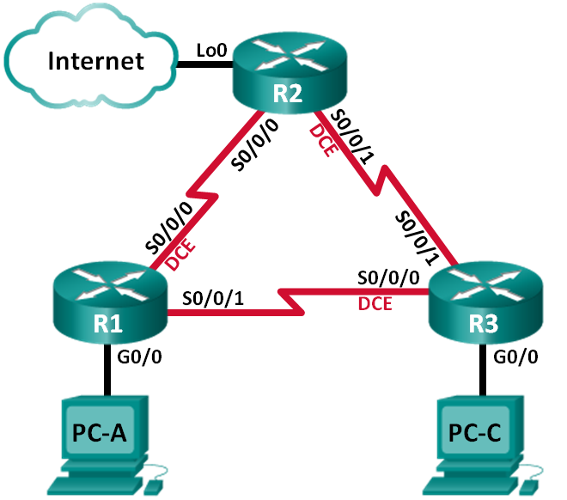

1. Addressing Table

|  |  |  |  |  |
| --- | --- | --- | --- | --- |
| Device | Interface | IP Address | Subnet Mask | Default Gateway |
| R1 | G0/0 | 192.168.1.1 | 255.255.255.0 | N/A |
|  | S0/0/0 (DCE) | 192.168.12.1 | 255.255.255.252 | N/A |
|  | S0/0/1 | 192.168.13.1 | 255.255.255.252 | N/A |
| R2 | Lo0 | 209.165.200.225 | 255.255.255.252 | N/A |
|  | S0/0/0 | 192.168.12.2 | 255.255.255.252 | N/A |
|  | S0/0/1 (DCE) | 192.168.23.1 | 255.255.255.252 | N/A |
| R3 | G0/0 | 192.168.3.1 | 255.255.255.0 | N/A |
|  | S0/0/0 (DCE) | 192.168.13.2 | 255.255.255.252 | N/A |
|  | S0/0/1 | 192.168.23.2 | 255.255.255.252 | N/A |
| PC-A | NIC | 192.168.1.3 | 255.255.255.0 | 192.168.1.1 |
| PC-C | NIC | 192.168.3.3 | 255.255.255.0 | 192.168.3.1 |

1. Objectives

Part 1: Build the Network and Load Device Configurations

Part 2: Troubleshoot OSPF

1. Background / Scenario

OSPF is a popular routing protocol used by businesses worldwide. A Network Administrator should be able to isolate OSPF issues and resolve those issues in a timely manner.

In this lab, you will troubleshoot a single-area OSPFv2 network and resolve all issues that exist.

**Note**: The routers used with CCNA hands-on labs are Cisco 1941 Integrated Services Routers (ISRs) with Cisco IOS Release 15.2(4)M3 (universalk9 image). Other routers and Cisco IOS versions can be used. Depending on the model and Cisco IOS version, the commands available and output produced might vary from what is shown in the labs. Refer to the Router Interface Summary Table at the end of this lab for the correct interface identifiers.

**Note**: Make sure that the routers have been erased and have no startup configurations. If you are unsure, contact your instructor.

1. Required Resources

* 3 Routers (Cisco 1941 with Cisco IOS Release 15.2(4)M3 universal image or comparable)
* 3 PCs (Windows 7, Vista, or XP with terminal emulation program, such as Tera Term)
* Console cables to configure the Cisco IOS devices via the console ports
* Ethernet and serial cables, as shown in the topology

1. Build the Network and Load Device Configurations

In Part 1, you will set up the network topology and configure basic settings on the PC hosts and routers.

* 1. Cable the network as shown in the topology.
  2. Configure PC hosts.
  3. Load router configurations.

Load the following configurations into the appropriate router. All routers have the same passwords. The privileged EXEC password is **class**. The password for console and vty lines is **cisco**.

Router R1 Configuration:

conf t

hostname R1

enable secret class

no ip domain lookup

interface GigabitEthernet0/0

ip address 192.168.1.1 255.255.255.0

duplex auto

speed auto

no shut

interface Serial0/0/0

bandwidth 128

ip address 192.168.12.1 255.255.255.252

ip ospf message-digest-key 1 md5 MD5LINKS

clock rate 128000

no shut

interface Serial0/0/1

bandwidth 64

ip ospf message-digest-key 1 md5 MD5LINKS

ip address 192.168.13.1 255.255.255.252

no shut

router ospf 1

auto-cost reference-bandwidth 1000

area 0 authentication message-digest

passive-interface g0/0

network 192.168.1.0 0.0.0.255 area 0

network 192.168.12.0 0.0.0.3 area 0

network 192.168.13.0 0.0.0.3 area 0

banner motd ^

Unauthorized Access is Prohibited!

^

line con 0

password cisco

logging synchronous

login

line vty 0 4

password cisco

login

transport input all

end

Router R2 Configuration:

conf t

hostname R2

enable secret class

no ip domain lookup

interface Loopback0

ip address 209.165.200.225 255.255.255.252

interface Serial0/0/0

bandwidth 182

ip ospf message-digest-key 1 md5 MD5LINKS

ip address 192.168.12.2 255.255.255.252

no shut

interface Serial0/0/1

bandwidth 128

ip ospf message-digest-key 1 md5 MD5LINKS

ip address 192.168.23.1 255.255.255.252

clock rate 128000

no shut

router ospf 1

router-id 2.2.2.2

auto-cost reference-bandwidth 1000

area 0 authentication message-digest

passive-interface g0/0

network 192.168.12.0 0.0.0.3 area 0

network 192.168.23.0 0.0.0.3 area 0

ip route 0.0.0.0 0.0.0.0 Loopback0

banner motd ^

Unauthorized Access is Prohibited!

^

line con 0

password cisco

logging synchronous

login

line vty 0 4

password cisco

login

transport input all

end

Router R3 Configuration:

conf t

hostname R3

enable secret class

no ip domain lookup

interface GigabitEthernet0/0

ip address 192.168.3.1 255.255.255.0

duplex auto

speed auto

no shut

interface Serial0/0/0

bandwidth 128

ip ospf message-digest-key 1 md5 MD5LINKS

ip address 192.168.13.2 255.255.255.252

clock rate 128000

no shut

interface Serial0/0/1

bandwidth 128

ip address 192.168.23.2 255.255.255.252

no shut

router ospf 1

router-id 3.3.3.3

area 0 authentication message-digest

passive-interface g0/0

network 192.168.3.0 0.0.0.255 area 0

network 192.168.13.0 0.0.0.3 area 0

network 192.168.23.0 0.0.0.3 area 0

banner motd ^

Unauthorized Access is Prohibited!

^

line con 0

password cisco

logging synchronous

login

line vty 0 4

password cisco

login

transport input all

end

* 1. Test end-to-end connectivity.

All interfaces should be up and the PCs should be able to ping the default gateway.

1. Troubleshoot OSPF

In Part 2, verify that all routers have established neighbor adjacencies, and that all network routes are available.

Additional OSPF Requirements:

* Each router should have the following router ID assignments:
  1. R1 Router ID: **1.1.1.1**
  2. R2 Router ID: **2.2.2.2**
  3. R3 Router ID: **3.3.3.3**
* All serial interface clocking rates should be set at 128 Kb/s and a matching bandwidth setting should be available to allow OSPF cost metrics to be calculated correctly.
* The 1941 routers have Gigabit interfaces, so the default OSPF reference bandwidth should be adjusted to allow cost metrics to reflect appropriate costs for all interfaces.
* OSPF should propagate a default route to the Internet. This is simulated by using Loopback interface 0 on R2.
* All interfaces advertising OSPF routing information should be configured with MD5 authentication, using **MD5LINKS** as the key.

List the commands used during your OSPF troubleshooting process:

_______________________________________________________________________________________

_______________________________________________________________________________________

_______________________________________________________________________________________

_______________________________________________________________________________________

List the changes made to resolve the OSPF issues. If no problems were found on the device, then respond with “no problems were found”.

R1 Router:

_______________________________________________________________________________________

_______________________________________________________________________________________

_______________________________________________________________________________________

_______________________________________________________________________________________

R2 Router:

_______________________________________________________________________________________

_______________________________________________________________________________________

_______________________________________________________________________________________

_______________________________________________________________________________________

R3 Router:

_______________________________________________________________________________________

_______________________________________________________________________________________

_______________________________________________________________________________________

_______________________________________________________________________________________

1. Reflection

How would you change the network in this lab so all LAN traffic was routed through R2?

_______________________________________________________________________________________

_______________________________________________________________________________________

_______________________________________________________________________________________

1. Router Interface Summary Table

|  |  |  |  |  |
| --- | --- | --- | --- | --- |
| Router Interface Summary | | | | |
| Router Model | Ethernet Interface #1 | Ethernet Interface #2 | Serial Interface #1 | Serial Interface #2 |
| 1800 | Fast Ethernet 0/0 (F0/0) | Fast Ethernet 0/1 (F0/1) | Serial 0/0/0 (S0/0/0) | Serial 0/0/1 (S0/0/1) |
| 1900 | Gigabit Ethernet 0/0 (G0/0) | Gigabit Ethernet 0/1 (G0/1) | Serial 0/0/0 (S0/0/0) | Serial 0/0/1 (S0/0/1) |
| 2801 | Fast Ethernet 0/0 (F0/0) | Fast Ethernet 0/1 (F0/1) | Serial 0/1/0 (S0/1/0) | Serial 0/1/1 (S0/1/1) |
| 2811 | Fast Ethernet 0/0 (F0/0) | Fast Ethernet 0/1 (F0/1) | Serial 0/0/0 (S0/0/0) | Serial 0/0/1 (S0/0/1) |
| 2900 | Gigabit Ethernet 0/0 (G0/0) | Gigabit Ethernet 0/1 (G0/1) | Serial 0/0/0 (S0/0/0) | Serial 0/0/1 (S0/0/1) |
| **Note**: To find out how the router is configured, look at the interfaces to identify the type of router and how many interfaces the router has. There is no way to effectively list all the combinations of configurations for each router class. This table includes identifiers for the possible combinations of Ethernet and Serial interfaces in the device. The table does not include any other type of interface, even though a specific router may contain one. An example of this might be an ISDN BRI interface. The string in parenthesis is the legal abbreviation that can be used in Cisco IOS commands to represent the interface. | | | | |